

**PROJECT REPORT**

A report submitted in partial fulfillment of the requirements for the



**Theater Management**

School of Computer Science & Engineering By

# Vaishnavi C Patil

PRN No: 22SC114281086 Roll No: 17

# Pradnya A Magennavar

PRN No: 22SC114281081 Roll No: 12

# 

# 

Program: BTech Class: SY BTech (Div.B)

Under Supervision of

# Mrs. Priyanka Koshti

Academic Year: 2023-2024



School of Computer Science & Engineering

**CERTIFICATE**

This is to certify that the “**Project Report**”

On

# “Theater Management”

submitted by

# Vaishnavi C Patil

PRN No: 22SC114281086 Roll No: 17

# Pradnya A Magennavar

PRN No: 22SC114281081 Roll No: 12

Program: BTech Class: SY BTech(Div B)

is work done by him/her and submitted during the 2022 – 2023 academic year, in partial fulfillment of the **Project.**

**Sanjay Ghodawat University, Kolhapur**

|  |  |  |  |
| --- | --- | --- | --- |
| **Mrs. Priyanka Koshti** | **Ms. Deepika Patil** |  |  |
| **Project Guide** | **PBL Co-ordinator and Head SOCSE** |  | **External** |



# DECLARATION

I the undersigned solemnly declare that the report of the project work entitled **“Theater Management”** which is carried out under the supervision of  **Mrs. Priyanka Koshti** I assert that the statements made and conclusions drawn are an outcome of the project work. I further declare that to the best of my knowledge and belief that the project report does not contain any part of any work which has been submitted for the award of any other degree/diploma/certificate in this University or any other University.

# Student Name:

# Student Name: Vaishnavi C Patil

PRN No: 22SC114281086 Roll No: 1

# Student Name: Pradnya A Magennavar

PRN No: 22SC114281081 Roll No: 12

**Class:** SY BTech (Div B)



# ACKNOWLEDGMENT

First, I would like to thank my Head of the School **Ms. Deepika Patil** for constructive criticism throughout my project. I would like to thank PBL coordinator **Ms. Deepika Patil** and Department Project Guide **Ms. Priyanka Koshti** for support and advices to get and complete internship in above said organization. It is indeed with a great sense of pleasure and immense sense of gratitude that I acknowledge the help of these individuals. I am extremely grateful to my department staff members and friends who helped me in successful completion of this project.



# ABSTRACT

# 

# The Theater Management Project is a comprehensive software system designed to stramline enhance the operations of a theater or cinema.This project leverages modern technology to offer an efficient and user-friendly platform for both theater administrators and patrons.

The Theater Management Project not only benefits theatergoers by simplifying the ticketing and booking process but also empowers theater administrators with data-driven insights to optimize operations and improve customer service. This software system represents a modern and innovative solution for the entertainment industry, fostering a seamless and enjoyable movie-watching experience.

# TABLE OF CONTENT’S

|  |  |  |
| --- | --- | --- |
| **SR.NO** | **Title** | **Page No.** |
| 1 | Introduction | 01-04 |
| 2. | Objective | 05 |
| 3 | System Requirements Specification(SRS) | 06 |
| 4 | Methodology | 07-08 |
| 5 | Implementation | 09-14 |
| 6 | Result | 15-17 |
| 7 | Conclusion And Future Scope | 18-19 |
| 8 | References | 20 |

# Introduction

## Introduction

Have you ever been excited to watch a movie or a play but got a little lost in the process of getting your tickets? That's where our Theater Management Project comes in! Imagine it as your helpful guide to everything theater-related. We've made it super simple for you to book tickets to your favorite shows. No more waiting in long lines! You can pick your seats, choose the time that works for you, and voilà – your tickets are ready. But wait, there's more! Our project also gives you all the cool details about the movies or plays. You'll know what the show is about, who's in it, and even watch trailers to get a sneak peek. It's like having your own personal movie guide.

So, whether you're a fan of action-packed movies or love a good comedy, our Theater Management Project is here to make sure you have a fantastic time – from booking your tickets to enjoying the show. Let's get ready for some big-screen excitement!

## Problem Definition:

# A Theater Management Project is a software-based system designed to efficiently and effectively manage the operations of a theater or cinema. It encompasses a wide range of functionalities and features that facilitate the seamless operation of a theater, enhance the patron experience, and streamline administrative tasks. The functionalities like displaying movie names ,there genera, duration, seat availability book ticket this functions are performed by this system.

## Scope:

## 

## The scope of this project is to create a simple interactive program for patrons. It provides patrons the menu option for users, they can choose any of the option from menu. The program defines structure for displaying movie names with there genera, index and duration and it has seat availability option as well as ticket booking option. While booking ticket users can view the available movies and seat layout visualization for selection of seat for a particular selected movie. It has a user friendly interface.

## Problem Identification:

# Tickets were typically physical paper that customer would receive after purchase.

# On the day of the show, customers would also walk up to the office and purchase tickets.

# Theaters would manually allocate seats to customers based on shows and availability.

# Payments were often made in cash, although some theaters might accept checks and credit cards

# Some theaters allowed customers to reserve tickets over the phone by there details.

# Objectives

# Show Information: Provide detailed information about each show.

# Real-time Availability: Display real-time availability of seats for each show, allowing patrons to choose from the available options instantly.

# Security and Data Privacy: Implement robust security measures to protect user data and financial transactions.

# Feedback Collection: Facilitate the collection of feedback from patrons.

# Efficient Ticket Booking: Simplify the ticket booking process for patrons.

# System Requirements Specification

## SOFTWARE REQUIREMENTS

* + Dev C++ /Code::Blocks / VS code

## HARDWARE REQUIREMENTS

* + 4 GB RAM
  + 500 GB HDD
  + I5 processor

# Methodology

## Algorithm:

* **Step 1:** Start.
* **Step 2:** It displays the main menu and user has to choose one option out of four.
* **Step 3:** If user selects first option then movie name is displayed.
* **Step 4:** If user selects second option it shows seat availability.
* **Step 5:** If user selects third option then user has to select the index along with rows and coloums.
* **Step 6:** If there is valid choice the ticket will be booked successfully.
* **Step 7:** Exit
* **Flow Diagram(Flow Chart):**

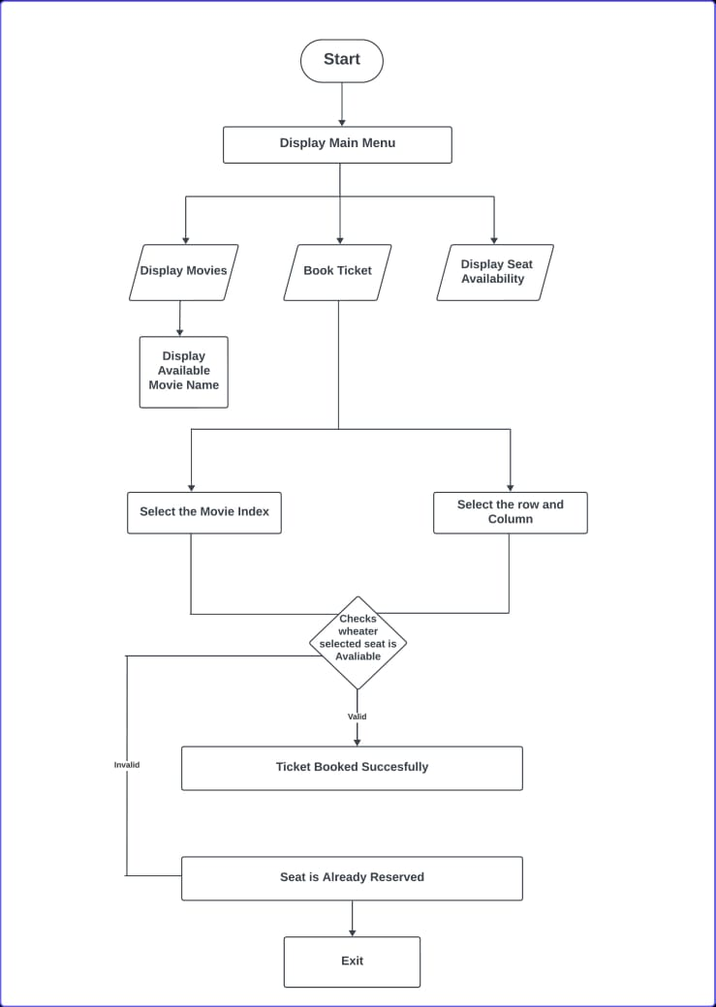

# Implementation

* Firstly it displays four options display movie, seat availability, ticket booking and exit .
* Catalog of Movies: Maintain an extensive database of movies with details such as genres, duration and index.
* Online Booking: Provide a user-friendly interface for customers to browse movies, choose seats, and make bookings online.
* Seat Selection: Allow customers to select seats interactively, user can choose by selecting rows and column of that seat. If the selected row and column is valid then it books ticket successfully.



**“Introduction of C++ Programming”**

C++ is a versatile and widely-used programming language known for its power and flexibility. It combines both high-level and low-level features, making it suitable for a wide range of applications, from system-level programming to creating software with complex logic. C++ emphasizes object-oriented programming, allowing developers to design and structure their code using classes and objects. It's highly efficient and provides control over memory management, making it popular infields like game development, system software, and embedded systems. C++ has a rich set of libraries and a strong community, making it a valuable choice for both beginners and experienced programmers.

**Advantages of learning C**++

* Versatility
* High Performance
* Object-Oriented
* Job Opportunities

## Source Code:

## #include<iostream>

## using namespace std;

## class display

## {

## public:

## display()

## {

## cout<<"WELCOME TO THEATER MANAGEMENT PROJECT"<<endl;

## cout<<"created by Vaishnavi and Pradnya"<<endl;

## }

## 

## void showdata()

## {

## cout<<"1.Display movies"<<endl;

## cout<<"2.Display seat availability"<<endl;

## cout<<"3.Book ticket"<<endl;

## cout<<"4.Exit"<<endl;

## cout<<endl;

## }

## 

## void Display_movies()

## {

## cout<<"available movies :"<<endl;

## cout<<"0.Avengers(Action)-150 min"<<endl;

## cout<<"1.Jawan(Action thriller)-120 min"<<endl;

## cout<<"2.The non(Horror)-145 min"<<endl;

## cout<<"---------------------------"<<endl;

## }

## 

## void Display_seat_availability()

## {

## cout<<"Seat avalibility:"<<endl;

## int i,j,row,coloumn;

## row=7;

## coloumn=7;

## for(i=1;i<=row;i++)

## {

## for(j=1;j<=coloumn;j++)

## {

## cout<<'O'<<" ";

## }

## cout<<endl;

## }

## cout<<"-----------------------------"<<endl;

## }

## 

## void Book_ticket()

## {

## cout<<"available movies :"<<endl;

## cout<<"0.Avengers(Action)-150 min"<<endl;

## cout<<"1.Jawan(Action thriller)-120 min"<<endl;

## cout<<"2.The non(Horror)-145 min"<<endl;

## cout<<"-------------------"<<endl;

## 

## int index;

## cout<<"select movie index:"<<endl;

## cin>>index;

## cout<<endl;

## switch(index)

## {

## case 0:

## cout<<"0.Avengers(Action)-150 min"<<endl;

## break;

## case 1:

## cout<<"1.Jawan(Action thriller)-120 min"<<endl;

## break;

## case 2:

## cout<<"2.The non(Horror)-145 min"<<endl;

## }

## cout<<"-----------------"<<endl;

## int Row,Column,i,j;

## Row=7;

## Column=7;

## for(i=1;i<=Row;i++)

## {

## for(j=1;j<=Column;j++)

## {

## cout<<'O'<<" ";

## }

## cout<<endl;

## }

## cout<<"---------------"<<endl;

## int row,column;

## cout<<"choose row and column to select a seat for booking"<<endl;

## cin>>row>>column;

## if(row>=1 && row<=Row && column>=1 && column<=Column)

## {

## cout<<"ticket booked successfully for index"<<index<<"and seat"<<row<<column<<endl;

## }

## else

## {

## cout<<"invalid position"<<endl;

## }

## cout<<"-------------------"<<endl;

## 

## }

## };

## int main()

## {

## display a;

## int choice;

## while (true) {

## a.showdata();

## cout << endl;

## cout << "Enter your choice: ";

## cin >> choice;

## switch (choice)

## {

## case 1:

## a.Display_movies();

## break;

## case 2:

## a.Display_seat_availability();

## break;

## case 3:

## a.Book_ticket();

## break;

## case 4:

## cout << "Exiting the program" << endl;

## return 0;

## default:

## cout << "Invalid choice" << endl;

## }

## }

## }

# Result

# 

OUTPUT 1:

First it displays menu for user to select the available option that user desire to know information about.

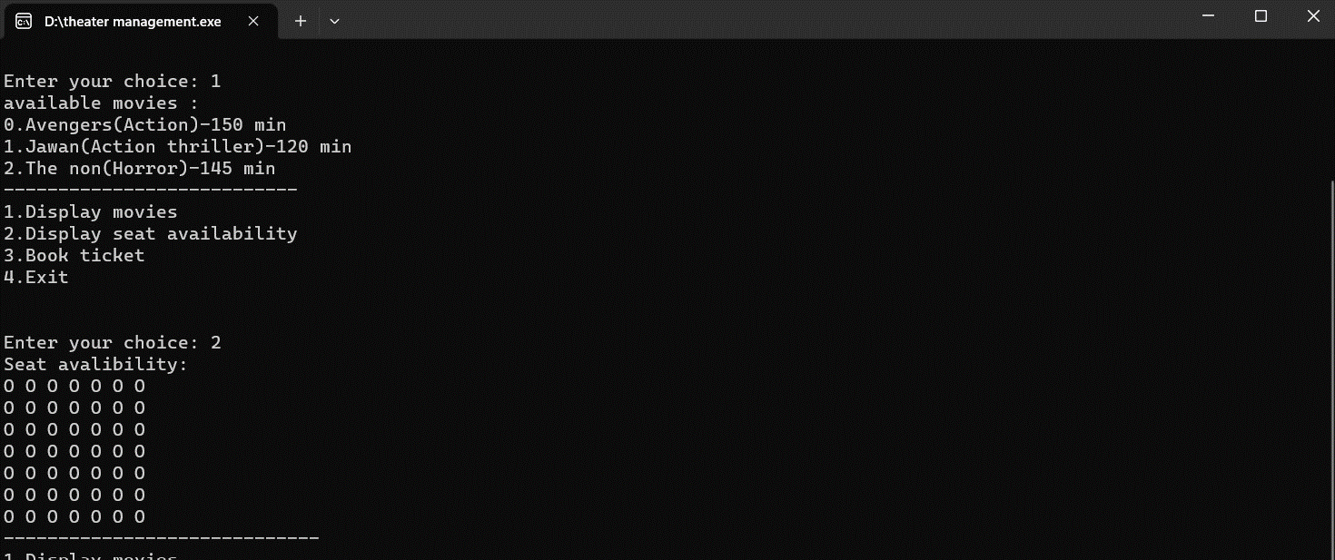

OUTPUT 2:

It asks users to enter there choice after entering first choice it displays available movies and after entering second choice it displays seat avalibility for users.

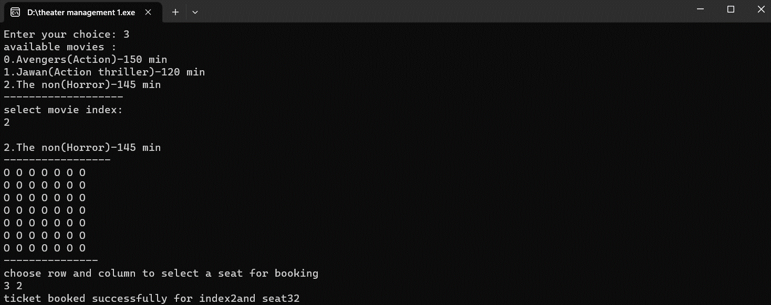

OUTPUT 3:

After entering choice three, it displays available movies and asks to select movie index for the desired movie. After that it displays seat layout visualization and asks to select the no of row and column for booking the desired seat. If the row and column is valid then it displays that seat booked successfully for a movie.

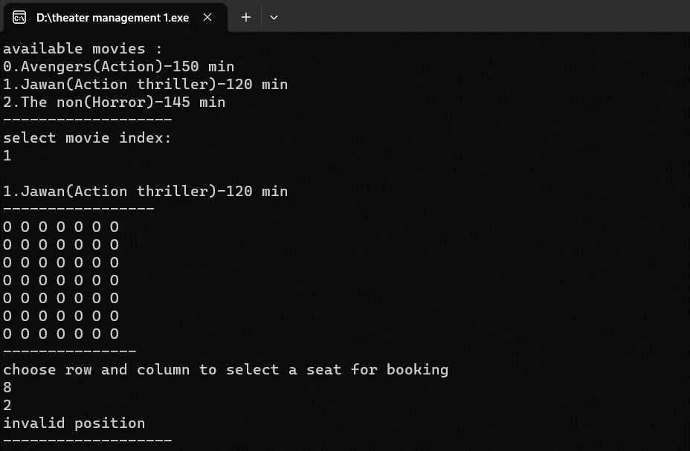

OUTPUT 4:

If user entered wrong row or column number then it displays invalid position.

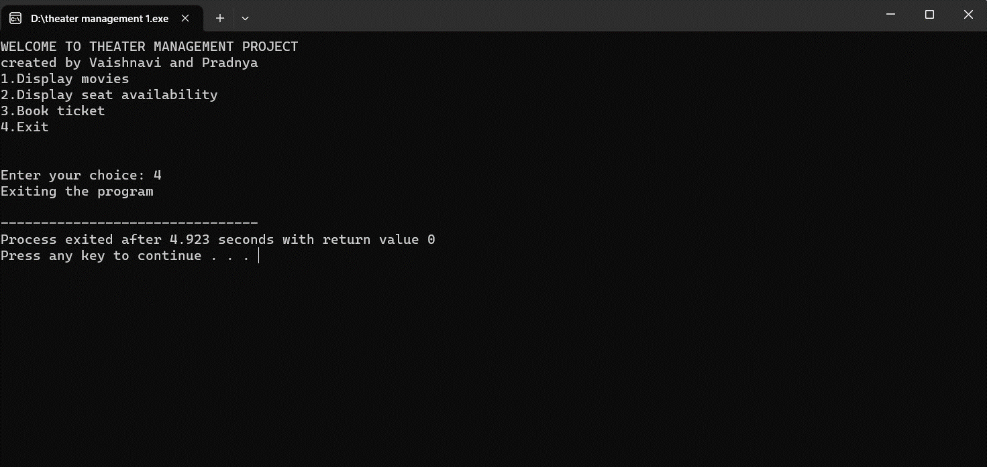

OUTPUT 5:

After entering the last option that is exit the program ends.

# Conclusion & Future Scope

## Future Scope:

## Dynamic Pricing: Implement dynamic pricing strategies that adjust ticket prices based on factors like demand, time of booking, and seat location. This can help maximize revenue during peak times.

## Augmented Reality (AR): Introduce AR features that allow customers to view virtual seat previews, theater layouts, and movie trailers when selecting seats or exploring the theater.

## Contactless Ticketing: Enhance contactless ticketing options, such as QR code ticketing, to minimize physical contact during the booking and entry process.

## In-Seat Ordering: Enable customers to order concessions, drinks, and snacks directly from their seats using a mobile app for in-theater delivery.

## Real-Time Feedback and Surveys: Collect real-time feedback from customers immediately after a movie ends to gather insights on their experience.

## Conclusion:

## 

## In conclusion, a theater management project is a dynamic and multifaceted system that plays a crucial role in ensuring the smooth operation of theaters and providing an enjoyable experience for both theater owners and customers. The primary objective of such a project is to streamline various aspects of theater management, including movie scheduling, ticket booking, seat allocation, and customer engagement.

# References

## Websites:

1. <https://chat.openai.com/c/46888189-065e-4267-b501-2a8154e12cc1>
2. <https://nevonprojects.com/theater-booking-system-project/>
3. <https://www.geeksforgeeks.org/constructors-c/>

**Books:**

1. Object oriented programming with C++ by E. Balagurusamy.
2. C++ Primer By-Barbara E Moo, Josee Lajoie and Stanley B. Lippman.